Computer Architecture Lab
(EL-2012)
LABORATORY REPORT

Fall 2026

(Lab#03)
Apply Behavioral-level Verilog to Design and Simulate Combinational Modules

Student Name: Muhammad Hamza Roll No: 24i-6513 Section: B

Date performed: 02 , Sep , 2026

MARKS AWARDED: ________ / 10

Signature and date of Instructor: _________________
Lab Instructors: Dr. Nasir Ali Shah, Engr. Fasih Ahmad

______________________________________________________________________________________________________________________________________________________

NATIONAL UNIVERSITY OF COMPUTER AND EMERGING SCIENCES, ISLAMABAD
Prepared by: | Fasih Ahmad |  | Version: 1.0
Verified by: | Dr. Nasir Ali Shah |  | Updated: Fall 2026

Task 1:

Description:
// Write description of the task here 👇 (max. five to seven lines)
This circuit takes two 4-bit numbers and uses a control signal to perform either addition or subtraction, producing a 4-bit result and a carry output.
Code:
module adder_subtractor_4bit (input [3:0] A,input [3:0] B,input mode, output reg [3:0] result, output reg cout);

always @ * begin
if (mode == 1'b0) begin
{cout, result} = A + B;
end
else begin
{cout, result} = A - B;
end
end

endmodule

module tb_adder_subtractor_4bit();
reg [3:0] A;
reg [3:0] B;
reg mode;
wire [3:0] result;
wire cout;

adder_subtractor_4bit uut (A,B,mode,result,cout);

initial begin
mode = 1'b0; A = 4'd5; B = 4'd3;
#20;

mode = 1'b0; A = 4'd12; B = 4'd6;
#20;

mode = 1'b1; A = 4'd9; B = 4'd4;
#20;

mode = 1'b1; A = 4'd5; B = 4'd5;
#20;
end
endmodule

Output:
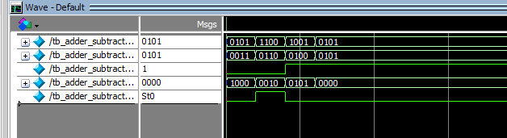

Task 2:

Description:
This circuit uses a 1-bit select line to choose between performing an AND operation (A & B) when select is 0, or an OR operation (A | B) when select is 1
Code:

module mux2x1_logic (
input A,
input B,
input Select,
output reg Y
);

always @ * begin
case (Select)
1'b0: Y = A & B;
1'b1: Y = A | B;
endcase
end

endmodule

module tb_mux2x1_logic;
reg A;
reg B;
reg Select;
wire Y;

mux2x1_logic uut (A,B,Select,Y);

initial begin
Select = 1'b0; A = 1'b0; B = 1'b1;
#20;
Select = 1'b0; A = 1'b1; B = 1'b1;
#20;
Select = 1'b1; A = 1'b1; B = 1'b0;
#20;
Select = 1'b1; A = 1'b0; B = 1'b0;
#20;
end
endmodule
Output:
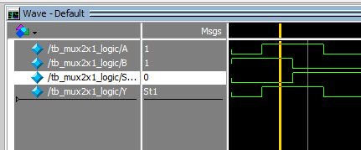
// Import output here 👇

Task 3:

Description:
// Write description of the task here 👇 (max. five to seven lines)
This circuit compares two 2-bit binary inputs to determine their relationship, turning on one output to show whether A is greater than, less than, or equal to B.

Code:
module comparator_2bit (input [1:0] A, input [1:0] B, output reg Greater, output reg Less, output reg Equal);

always @ * begin
Greater = 1'b0;
Less = 1'b0;
Equal = 1'b0;

if (A > B)
Greater = 1'b1;
else if (A < B)
Less = 1'b1;
else
Equal = 1'b1;
end

endmodule

module tb_comparator_2bit;
reg [1:0] A;
reg [1:0] B;
wire Greater;
wire Less;
wire Equal;

comparator_2bit uut ( A,B, Greater, Less, Equal );

initial begin
A = 2'b00; B = 2'b00;
#20;
A = 2'b01; B = 2'b10;
#20;
A = 2'b11; B = 2'b01;
#20;
A = 2'b10; B = 2'b10;
#20;
end
endmodule

Output:
// Import output here 👇
